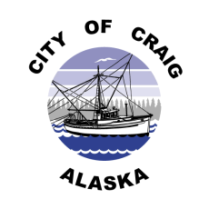
Job Opening

Job Title: Lifeguard I

Pay Rate: $10.66/hr. - $14.13/hr. DOE (Grade 1)
Part-time position

Department: Aquatic Center, City of Craig

Date Posted: September 5, 2023

Position Summary
Under the general direction and supervision of the Aquatic Center Manager, the Lifeguard I ensures the safety of all pool patrons, enforces all City of Craig Aquatic Center rules and performs rescue procedures in the event of an emergency. They perform maintenance duties and other miscellaneous duties as assigned.

*All training provided.

Qualifications
- Must be 15 years of age or older.
- Must possess (or obtain upon hire) valid Red Cross Lifeguarding/First Aid/CPR/AED Certification.
- Red Cross WSI Certification recommended.
- Must maintain a level of physical fitness necessary to perform job functions.
- Must attend all staff meetings and in-service training sessions.
- All lifeguards are expected to wear the uniform provided to them and arrive at the workplace on days expected in a timely manner.
- The person holding this position must possess leadership qualities and quick decision-making skills.
.
Applications
Complete job description and application are available at City Hall, 500 Third Street, or online at www.craigak.com. Please submit completed applications to hr@craigak.com,or drop off at City Hall. Position open until filled.

The City of Craig is an Equal Opportunity Employer

