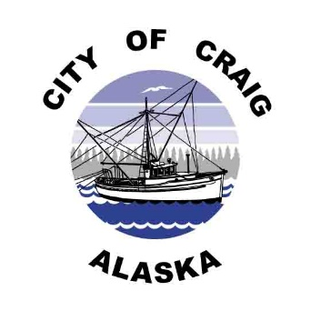
Job Opening
Posted July 9, 2020
Job Title: Receptionist II/Cash Receipt Clerk
Pay Rate: $17.17hr.- $20.19hr. DOE
Pay Grade: 3
Department: Administration

Position Summary
Under the general direction and supervision of the Finance Director, the Receptionist/Cash Receipts Clerk performs and completes the necessary tasks relating to cash receipts and performs general office duties.
Duties & Responsibilities
- Perform all tasks relating to cash receipts.
- Maintain city businesses’ sales tax records and send quarterly reports.
- Perform general office duties.
- Perform all other duties as directed.
Qualifications
- High school diploma or equivalent preferred.
- Must be prompt and courteous to all customers.
- Must have knowledge of office machines including fax, 10-key calculator, and computers.
- Must have basic Microsoft Office skills including Word, Excel, Outlook and Publisher.
- Must be detail-oriented, punctual, flexible, able to meet deadlines, and able to multitask.
Applications
Complete job description, qualifications/requirements, and job application are available at City Hall, 500 Third Street, or online at www.craigak.com. Please submit completed applications to hr@craigak.com, or drop off at City Hall.
The City of Craig is an Equal Opportunity Employer

