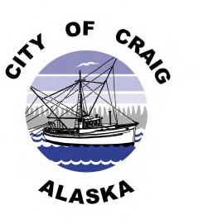

CITY OF CRAIG PUBLIC NOTICE

Invitation to Bid / October 6, 2023

City of Craig is soliciting sealed offers from interested parties for the sale of the following items: Clear Titles on all Three Vehicles.

1995 Nissan LL Pick Up, Red in Color (No Keys) Poor Condition
CPD 23-05139

1997 Ford F150, Maroon in Color (No Keys) Fair Condition
CPD 23-06175

1998 Subaru LEG SW, Red in Color (Have Keys, Run’s) Fair Condition
CPD 23-03068

Minimum bid for each vehicle is $50.00 dollars. Official Bid Forms are available at Craig City Hall or Craig Police Department.

The vehicles are available for inspection at the City of Craig Police Impound Yard, Craig Alaska. To schedule an appointment call CPD Dispatch at 907-826-3330

For more information, please contact Craig Police Department at 907-826-3330.

Closes at 3:00 PM Monday, October 16, 2023

