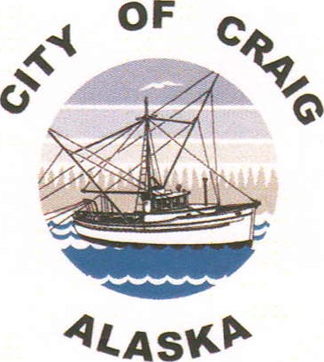
City of Craig Official Bid Form
Bid Item:

Bid Amount: $ (No minimum bid requirements)

Printed Name:

Address:

Phone:

Bid items will need to be picked up within a week of notification of award. The purchaser will need to pay for items at the City Office and provide receipt of payment for pick up. If items are not picked up within a week of notification of award, the item will be offered to the next highest bidder.
I have read the bid documents and understand I am solely responsible for all costs in the removal of/repairs to/or storage of this item. I further understand that the City of Craig does not guarantee any of the bid items in any way.
Signature:

Date:

SEALED BIDS DUE NO LATER THAN:
3:00 p.m. on Tuesday, June 21, 2022

