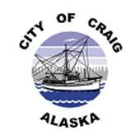
CITY OF CRAIG
Invitation to Bid and Official Bid Form
The City of Craig Public Works Department is soliciting sealed offers from interested parties for sale of the following items:
Vehicle | Description | Minimum Bid
1999 Ford Sterling dump truck  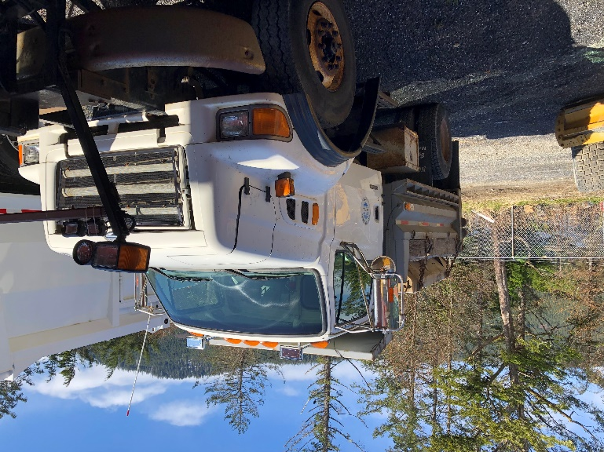 | The Sterling dump truck, sander, and plow will be sold/bid as one unit. Everything is sold as is. The Ford Sterling has 5,204.6 hours, and 33,292.8 miles. | $8,500.00
2001 Freightliner garbage truck  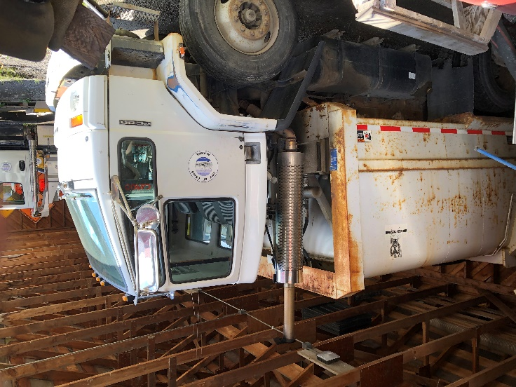 | The truck has 14,978.6 hours, and 51,070 miles | $3,000.00
2006 Ford F150 PK | Black. The driver side front tire leaks. Has key and runs good. All forward gears work, but reverse does not. | $2,500
2000 Chevy Pick Up | Black. Runs. Lots of exposed wiring and paneling. Has key. All tires hold air. | $200.00
2007 Ford FUS | Black. 4 door car. Runs great. Has key. Passenger rear tire leaks. | $300.00
2004 F150 Pick Up  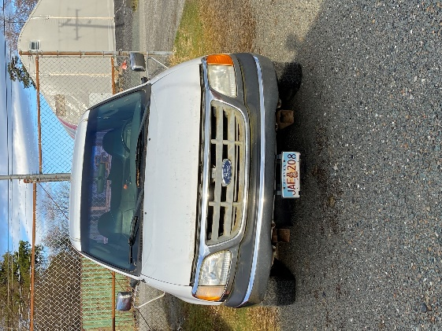 | White. Runs. Has keys. Driver front tire has a slow leak. | $200.00
2008 Ford Expedition |  | $150.00
1996 Chevy S10 Pick Up  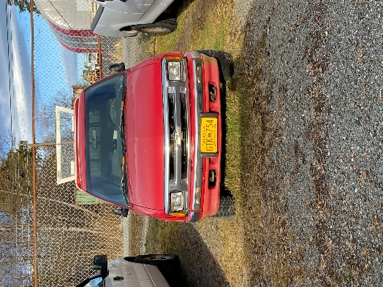 | Red. Has a camper shell. No keys, not sure if it runs | $50.00
1991 Chevy Van | Tan. Runs. Has keys. Currently at public works yard | $150

